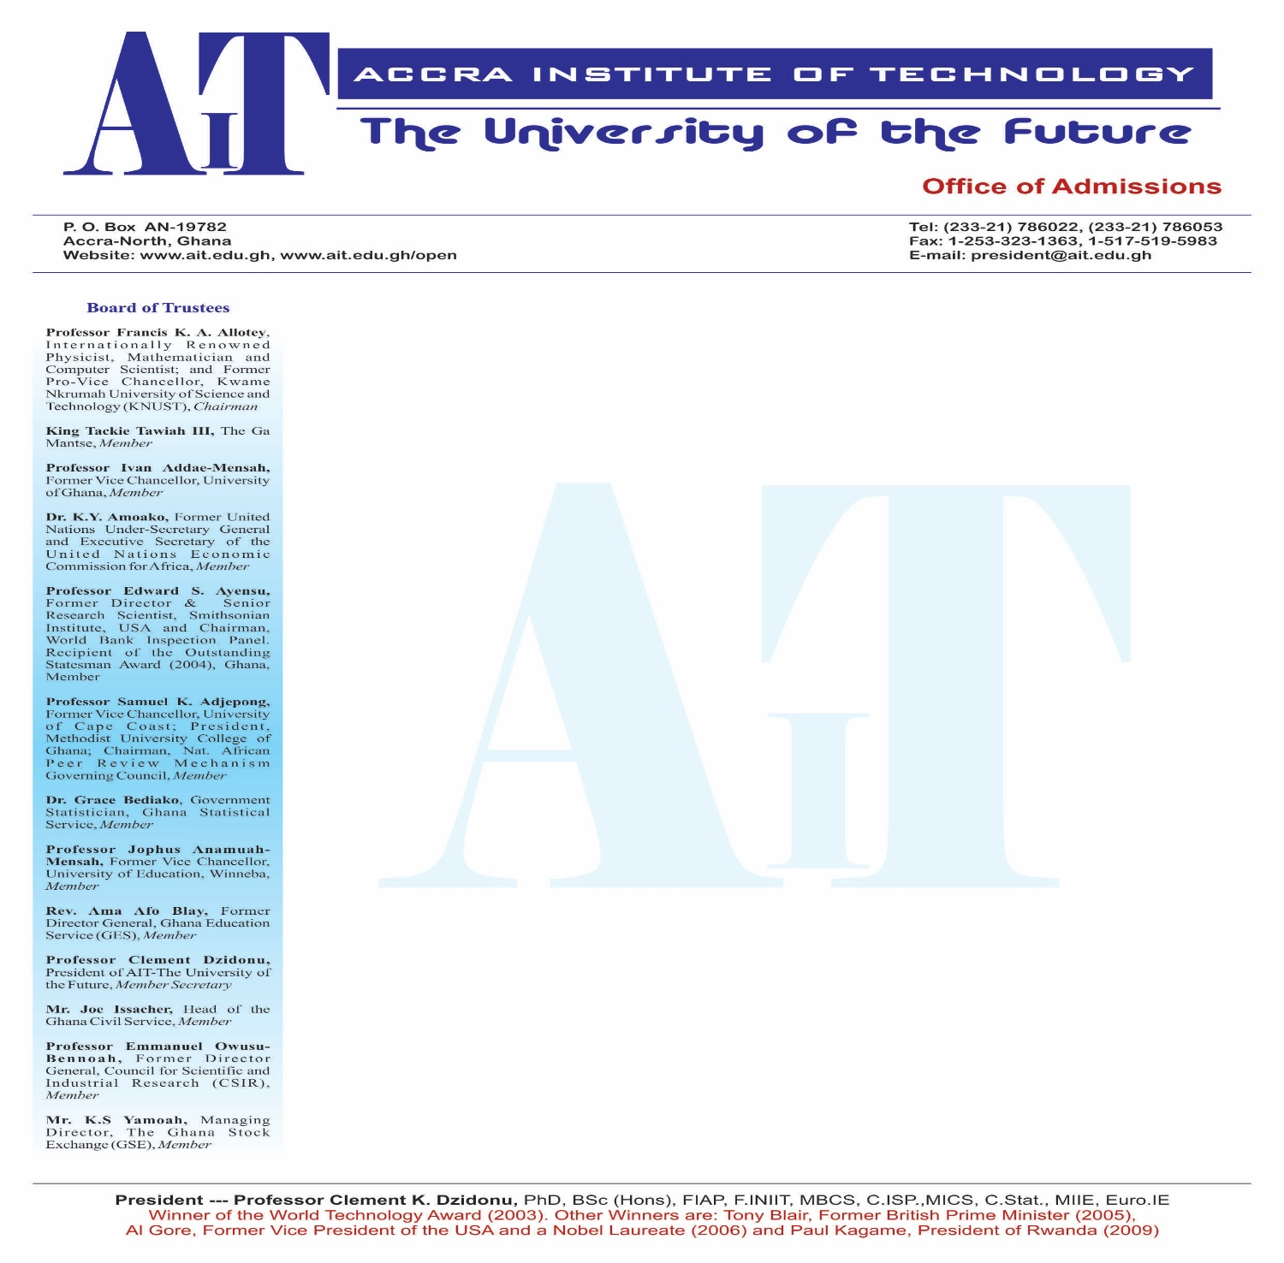

**BACKLOG CLEARANCE PROGRAMME**

**MGT305: INTERNATIONAL BUSINESS MANAGEMENT**

**FEBRUARY 2023**

**NAME OF LECTURER: CARL-REINDOLPH ASANTE**

**INSTRUCTIONS TO CANDIDATES**

**ANSWER ALL QUESTIONS**

CASE ONE: MERGERS AND ACQUISITIONS IN GHANA’S TELECOM INDUSTRY

M & A activities in Ghana have been notable in the telecommunication industry. The telecom industry’s transformational process in Ghana has made it a very vital component for development. Previously, Ghana’s telecom industry was characterized by monopoly, low tariffs and inefficiencies. It was based on this that the Government of Ghana decided to sell part of Ghana Telecom (GT) to Telekom Malaysia Berhard. This led to the first ever merger in the telecommunications industry in Ghana which was a three-year Technical Services Agreement (TSA) where G-Com Limited, a consortium led by Telekom Malaysia Berhard acquired 30% shares of Ghana Telecom from the Government of Ghana (GOG) for USD 30 million on the 20th of February 1997. This led to the first ever merger in the telecommunications industry in Ghana which was a three year Technical Services Agreement (TSA) where G-Com Limited, a consortium led by Telekom Malaysia Berhard acquired 30% shares of Ghana Telecom from the Government of Ghana (GOG) for USD 30 million on the 20th of February 1997.

Another interesting acquisition, which can be described as the GSM evolution in Ghana, also started essentially in November 1996 with the launch of the first GSM service by Scancom Limited under the brand name of Spacefon. In September 2007, Africa’s largest mobile group, Mobile Telecommunications Network (MTN) acquired Investcom Limited which owned Scancom (GH) Ltd. the operators of Areeba in Ghana. MTN offered to acquire the Areeba’s holding company Investcom for $5.5 billion, as part of its growth strategy in emerging markets. At the end of 2005 Investcom had 4.9 million customers in Africa, the Middle East and Europe. The Beirut-based company had owned mobile operations in Benin, Cyprus, Ghana, Guinea Bissau, Liberia, Sudan, Syria and Yemen as at that time. MTN offered USD3.83 per Investcom share and an alternative of USD2.08 in cash and 0.18 MTN shares per Investcom share.

In October 2007 Celtel International, a subsidiary of Kuwaiti based Zain Telecom (formerly named the MTC Group) announced it had signed an agreement to acquire 75% of Western Telesystems Ltd (Westel) from the Government of Ghana for USD 120 million. The Government of Ghana remained a shareholder in Westel with a 25% holding at that time of the purchase through the Ghana National Petroleum Corporation (GNPC). Bharti Airtel in 2010 also acquired Zain Telecom’s African operations for $10.7 billion of which Zain Ghana was a subsidiary. M & A deals carried out in Ghana’s telecom industry from 2004 to 2016 is estimated at $1.92 billion***.***

In recent times, Airtel had been in talks with rival Millicom International Cellular (Tigo) for a possible merger in Ghana, a deal which has long been sealed, seeing the birth of a new company (AirtelTigo). Also, the National Communication Authority of Ghana has granted Vodafone International Holdings [(VOD.L)](https://www.reuters.com/companies/VOD.L) approval to sell its 70% stake in Vodafone Ghana to Telecel Group.

**Requirement**

1. How different is Merger from Acquisitions. Discuss their distinguishing characteristics

8 marks

1. Examine five factors that will warrant foreign entities to enter into mergers and acquisitions (5 marks each = 25 marks)
2. From your knowledge in FDIs, which of the two will you recommend to an international business manager. Merger or Acquisition, and Why. 8 marks
3. From the case above, it could be said that the foreign entities that have ventured into M& As could have considered Greenfield Investment as an alternative.

i) Discuss possible reasons why such investment alternative was not considered by them

8 marks

ii) Evaluate the pros of greenfield investment to a potential IB Manager 8 marks

1. Using any key performance indicator (KPI) of your choice, evaluate whether or not the merger between Airtel and Tigo has been successful.

*(****Note****: each student should use different KPIs) 8 marks*

1. Examine how the many M&As in the telecom sector have impacted the economy of Ghana. 8 marks
2. Clearly, no firm will penetrate a new market without scanning its environment to weigh its cost and benefits. Evaluate three (3) possible environmental factors these foreign entities might have checked before penetrating the telecom business in Ghana.

(3 marks each = 9 marks)

1. Vodafone Ghana is currently in the process of being acquired by Telecel, an Africa-focused telecommunication service provider and a leader in digital service. As an international business student, assess how Telecel’s entry will impact the telecom industry in Ghana. (8 marks)

***Presentation of work*** = (10 marks)

**Total score = 100 marks**

GOO***D LUCK***